 | Projekt | / Bildrechte
 | 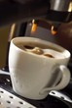 | 27324164 - cup of coffee  © FOOD-images
88021688 - Eine Gruppe von vielfältigen Menschen bildet eine Einheit als Team
© Thaut Images
91345110 - senior woman hand putting money to piggy bank
© Syda Productions
93092556 - Seniors in the kitchen
© pressmaster
96957133 - Baby boy in white sunny bedroom
© famveldman
114120711 - Four businessman are trying to come to an agreement
© Andrey Burmakin
 | 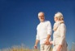 | 102001544 - happy senior couple talking outdoors  © Syda Productions
113601950 - Boy and puppy
© ivanko80
109439683 - Business partnership meeting. Picture businessmans handshake. Successful businessmen handshaking after good deal. Horizontal, blurred background
© kantver
 | 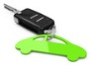 | 52825484 - Der Autoschlüssel  © beermedia
43910924 - Zufriedener Handwerker in der Ausbildung
© Volker Witt
 | 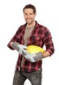 | 54644486 - Junger lächelnder Bauarbeiter  © Peggy Blume
 | 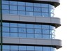 | 603802 - bürokomplex  © Michael Homann
 | 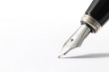 | 26237987 - 万年筆1  © J_PLUS
 | 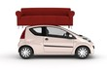 | 37339357 - Need a transporter??  © arsdigital
 | 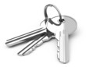 | 52183112 - Der Schlüsselbund  © beermedia
 | 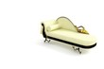 | 36303186 - Chaiselonge antique  © arsdigital
32367598 - Smiling mature business man with mobilephone
© Günter Menzl
 | 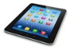 | 47813388 - Tablet computer  © Scanrail
 | 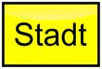 | 34900886 - Stadt - Schild  © fotografiedk
53674839 - Jetzt kaufen - Button
© cirquedesprit
 | 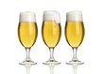 | 27297978 - 3 pils freisteller  © akf
27199568 - pilstulpe mit schaum
© akf
11610259 - Workers
© Kurhan
19550739 - Dartpfeil im Bull´s Eye
© Henry Schmitt
40561427 - Rotes Schleifenband
© Artenauta
 | 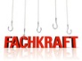 | 40409745 - Fachkräfte angeln  © bluedesign
22904685 - Vater und Tochter
© MAK
45065675 - Mann im Büro
© Jeanette Dietl
45894868 - Mann hält Tabletpc
© Amir Kaljikovic
 | 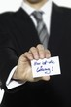 | 10153661 - Hier ist die Lösung  © Kim Schneider
2345798 - teamwork
© Yuri Arcurs
12331389 - Portrait of attractive young female showing a thumbs up
© Yuri Arcurs
 | 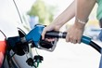 | 9250202 - Tanking up with gasoline  © Zoe
286937 - group business team
© Philip Date
6190361 - Erfolg
© Kim Schneider
2204090 - your empty board
© ioannis kounadeas
 | 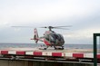 | 934361 - ec 130  © Martin
9961539 - heliport (image can be used for printing or web)
© appler
18401067 - Man Paying Bills and Worrying
© forestpath
28419717 - Young woman with a cocktail.
© Wrangler
 | 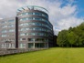 | 34164712 - Office near park  © creativenature.nl
3940894 - Can't Get You Out Of My Head
© Darren Baker
29669228 - Executive under stress
© Yuri Arcurs
 | 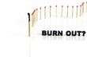 | 35808940 - Burn Out Erkrankung  © Gunnar Assmy
28151596 - businessman works with huge 3D panel
© AA+W
18401067 - Man Paying Bills and Worrying
© forestpath
28419717 - Young woman with a cocktail.
© Wrangler
36950995 - weinen
© drubig-photo
 | 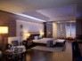 | 14150707 - Hotel_room  © fair image
32708377 - Cloud computing
© Beboy
 | 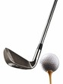 | 6118181 - golf  © mediamo
 | 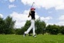 | 8628062 - Golf Player  © Ray
 | 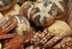 | 10814360 - Brotkorb  © Ilka Burckhardt
 | 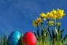 | 6265367 - Ostern  © Rebel
 | 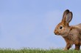 | 10938816 - Hase auf der Wiese  © Carola Schubbel
 | 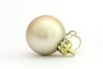 | 10076336 - New Year toy  © Julia Mashkova
2787454 - kerzenschein - weihnachten
© Daniel Fleck
2787454 - kerzenschein - weihnachten
© Daniel Fleck
9248517 - Weihnachtsschmuck, Kerzen
© Westend61

